

cd
SAVEETHA SCHOOL OF ENGINEERING
SAVEETHA INSTITUTE OF MEDICAL AND TECHNICAL SCIENCES

A

HACKATHON PROJECT

REPORT

PROJECT TITLE

HEALTHCARE ANALYSIS & PATIENT INSIGHTS

REPORT SUBMITTED BY

G PAVAN KUMAR (192210610)
P KOUSHIK REDDY(192210696)
MAANASA (192210382)
MONISHA(192225046)
S. SAI SARANYA(192224279)

REPORT SUBMITTED TO

HCL TEAM

(PPT)

TEAM STRUCTURE & ROLES :

TEAM | NAME | ROLE | PPT
SNOWCREW | G PAVAN KUMAR | ROLE_PLATFORM_ADMIN _ANAYST | LINK
SNOWCREW | P.KOUSHIK REDDY | ROLE_DATA_MODELER
SNOWCREW | P.MAANASA | ROLE_DATA_QUALITY
SNOWCREW | K.MONISHA | ROLE_DATA_ENGINEER
SNOWCREW | S.SARANAYA | ROLE_DATA_ENGINEER

TIMELINE :

S.NO | DESCRIPTION | 27.04.2026 | 27.04.2026 | 27.04.2026
1. | SPRINT 0: DESIGNING
2. | SPRINT 1 : IMPLEMENTATION AND CODING
3. | SPRINT 2 : INTEGRATION AND PRESENTATION

Fig. 1 Timeline chart

SPRINT 0 : Designing Phase (30 Minutes)
A)Flow Diagram

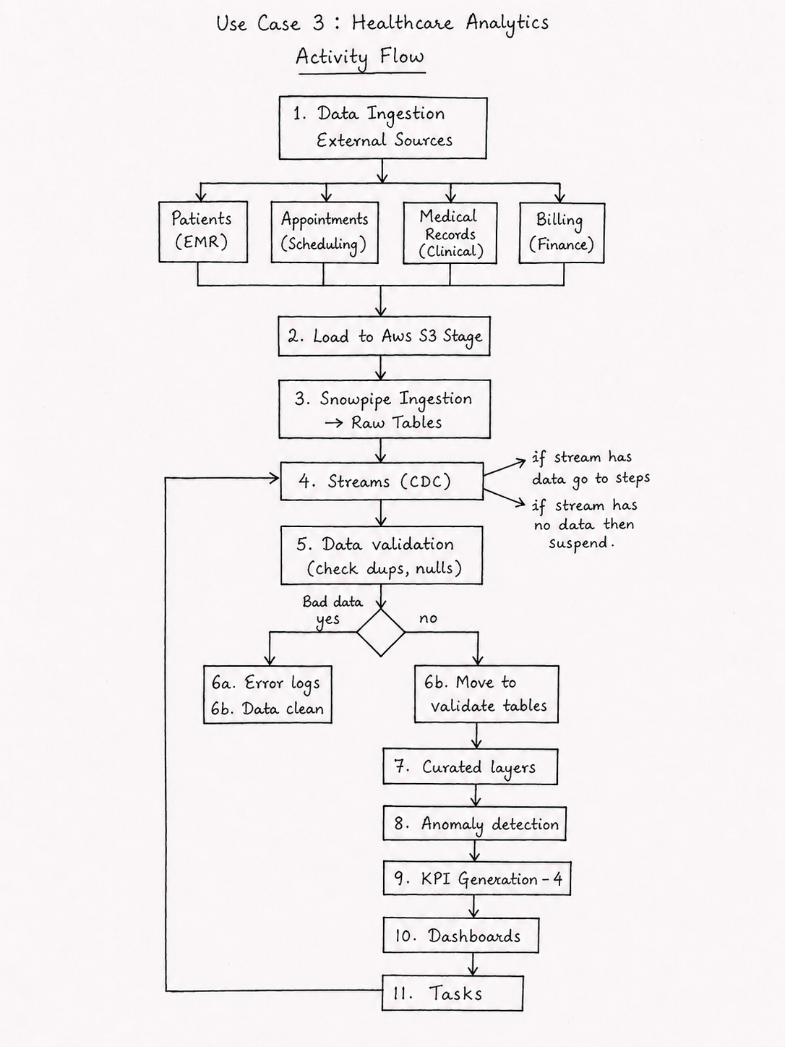
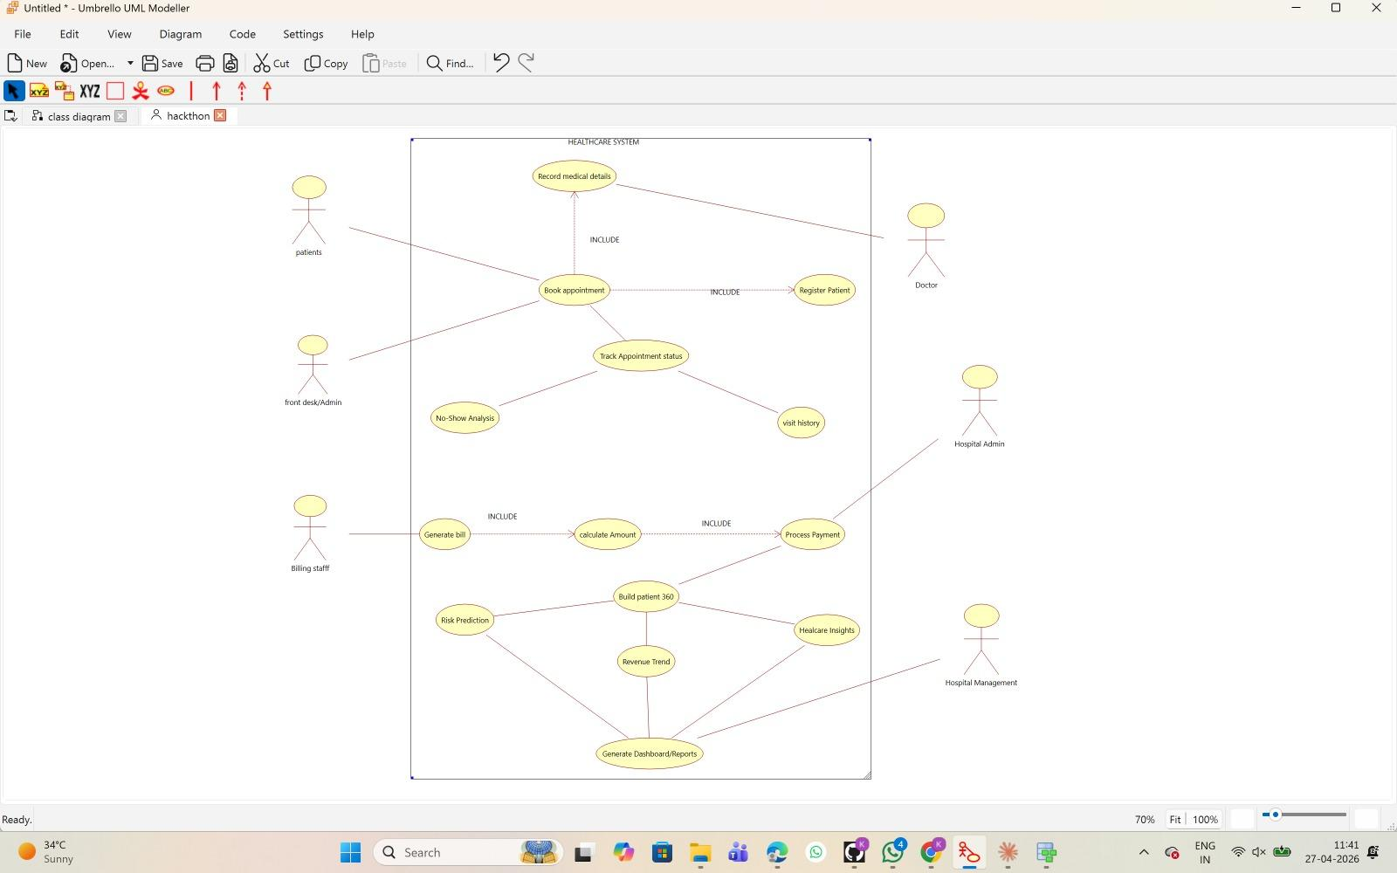
B)uSE CASE Diagram

- This diagram represents a Healthcare System Use Case Model showing interactions between users and system functionalities.
- It includes actors like patients, doctors, admin, billing staff, and hospital management connected to key operations.
- Core processes such as appointment booking, billing, patient registration, and analytics (risk prediction, revenue trends) are highlighted.
- Overall, it demonstrates how the system supports both operational tasks and decision-making insights in healthcare.

C)Data Modelling(Star Schema)
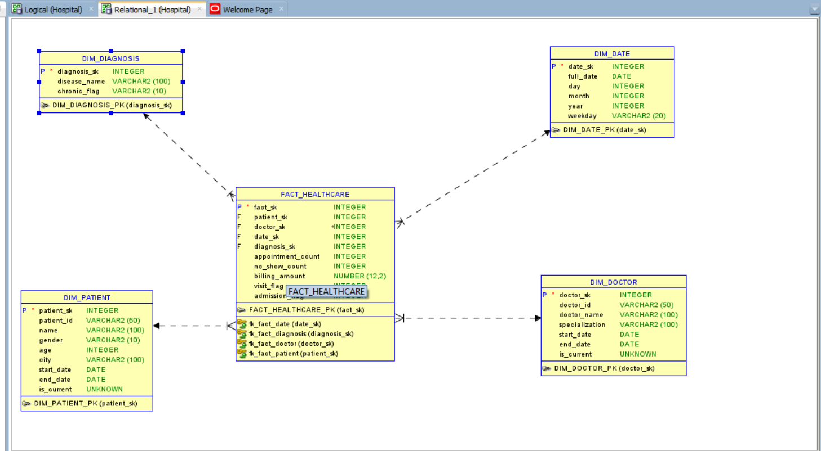

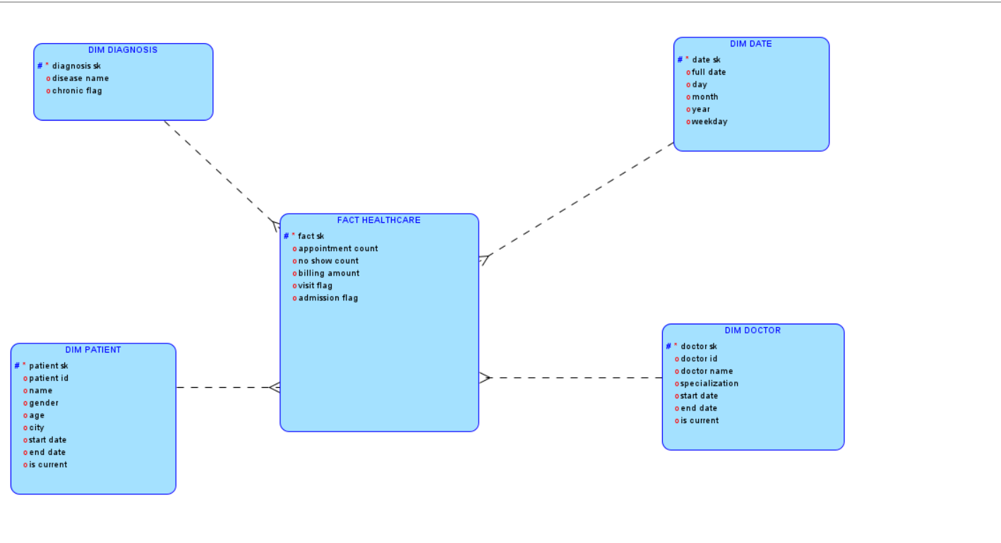
SPRINT 1 : IMPLEMENTATION AND CODING
create database hackathon_db;

CREATE SCHEMA RAW;
CREATE SCHEMA VALIDATED;
CREATE SCHEMA CURATED;
CREATE SCHEMA ANALYTICS;
CREATE SCHEMA CONTROL;
CREATE SCHEMA UTIL;
CREATE SCHEMA TASKS;

-------------------------------------------------------

CREATE SCHEMA IF NOT EXISTS CONTROL;

CREATE OR REPLACE TABLE CONTROL.ERROR_LOG (
table_name STRING,
error_type STRING,
record_data VARIANT,
error_time TIMESTAMP DEFAULT CURRENT_TIMESTAMP
);

USE SCHEMA CONTROL;
CREATE OR REPLACE TABLE CONTROL.ANOMALY_LOG (
anomaly_type STRING, -- e.g., 'HIGH_BILLING', 'SCHEDULE_CLASH'
record_id STRING, -- ID of the patient, doctor, or bill causing the issue
description STRING, -- Human-readable detail about the anomaly
detected_at TIMESTAMP DEFAULT CURRENT_TIMESTAMP() -- When it was caught
);
---------------------------------------------------------------

CREATE OR REPLACE FILE FORMAT UTIL.CSV_FORMAT
TYPE = 'CSV'
SKIP_HEADER = 1
FIELD_OPTIONALLY_ENCLOSED_BY = '"'
NULL_IF = ('NULL','null','');

CREATE OR REPLACE STORAGE INTEGRATION S3_INT
TYPE = EXTERNAL_STAGE
STORAGE_PROVIDER = S3
ENABLED = TRUE
STORAGE_AWS_ROLE_ARN = 'arn:aws:iam::110695445731:role/hacakthon'
STORAGE_ALLOWED_LOCATIONS = ('s3://hackathonb12003/pipes/');

desc STORAGE INTEGRATION S3_INT;
CREATE OR REPLACE STAGE UTIL.HEALTH_STAGE
URL='s3://hackathonb12003/pipes/'
STORAGE_INTEGRATION = S3_INT
FILE_FORMAT = UTIL.CSV_FORMAT;

list @UTIL.HEALTH_STAGE;

USE SCHEMA RAW;

CREATE TABLE PATIENTS_INC (
patient_id STRING,
name STRING,
gender STRING,
age STRING,
city STRING,
load_ts TIMESTAMP DEFAULT CURRENT_TIMESTAMP()
);

CREATE TABLE DOCTORS_INC (
doctor_id STRING,
doctor_name STRING,
specialization STRING,
load_ts TIMESTAMP DEFAULT CURRENT_TIMESTAMP()
);

CREATE TABLE APPOINTMENTS_INC (
appointment_id STRING,
patient_id STRING,
doctor_id STRING,
appointment_date STRING,
status STRING,
visit_type STRING,
load_ts TIMESTAMP DEFAULT CURRENT_TIMESTAMP()
);

CREATE TABLE BILLING_INC (
billing_id STRING,
patient_id STRING,
billing_date STRING,
amount STRING,
load_ts TIMESTAMP DEFAULT CURRENT_TIMESTAMP()
);

CREATE TABLE MEDICAL_INC (
record_id STRING,
patient_id STRING,
disease STRING,
severity STRING,
chronic_flag STRING,
load_ts TIMESTAMP DEFAULT CURRENT_TIMESTAMP()
);

CREATE OR REPLACE PIPE patients_pipe
AUTO_INGEST = TRUE
AS
COPY INTO RAW.PATIENTS_INC (
patient_id,
name,
gender,
age,
city
)
FROM @UTIL.HEALTH_STAGE/patients/
FILE_FORMAT = (FORMAT_NAME = UTIL.CSV_FORMAT)
ON_ERROR = 'CONTINUE';

CREATE OR REPLACE PIPE doctors_pipe
AUTO_INGEST = TRUE
AS
COPY INTO RAW.DOCTORS_INC (
doctor_id,
doctor_name,
specialization
)
FROM @UTIL.HEALTH_STAGE/doctors/
FILE_FORMAT = (FORMAT_NAME = UTIL.CSV_FORMAT)
ON_ERROR = 'CONTINUE';

CREATE OR REPLACE PIPE appointments_pipe
AUTO_INGEST = TRUE
AS
COPY INTO RAW.APPOINTMENTS_INC (
appointment_id,
patient_id,
doctor_id,
appointment_date,
status,
visit_type
)
FROM @UTIL.HEALTH_STAGE/appointments/
FILE_FORMAT = (FORMAT_NAME = UTIL.CSV_FORMAT)
ON_ERROR = 'CONTINUE';

CREATE OR REPLACE PIPE billing_pipe
AUTO_INGEST = TRUE
AS
COPY INTO RAW.BILLING_INC (
billing_id,
patient_id,
billing_date,
amount
)
FROM @UTIL.HEALTH_STAGE/billing/
FILE_FORMAT = (FORMAT_NAME = UTIL.CSV_FORMAT)
ON_ERROR = 'CONTINUE';

CREATE OR REPLACE PIPE medical_pipe
AUTO_INGEST = TRUE
AS
COPY INTO RAW.MEDICAL_INC (
record_id,
patient_id,
disease,
severity,
chronic_flag
)
FROM @UTIL.HEALTH_STAGE/medical/
FILE_FORMAT = (FORMAT_NAME = UTIL.CSV_FORMAT)
ON_ERROR = 'CONTINUE';

show pipes;

select system$pipe_status('HACKATHON_DB.RAW.APPOINTMENTS_PIPE');
select system$pipe_status('HACKATHON_DB.RAW.BILLING_PIPE');
select system$pipe_status('HACKATHON_DB.RAW.DOCTORS_PIPE');
select system$pipe_status('HACKATHON_DB.RAW.MEDICAL_PIPE');
select system$pipe_status('HACKATHON_DB.RAW.PATIENTS_PIPE');

CREATE OR REPLACE STREAM RAW.PATIENTS_STREAM ON TABLE RAW.PATIENTS_INC;
CREATE OR REPLACE STREAM RAW.DOCTORS_STREAM ON TABLE RAW.DOCTORS_INC;
CREATE OR REPLACE STREAM RAW.APPOINTMENTS_STREAM ON TABLE RAW.APPOINTMENTS_INC;
CREATE OR REPLACE STREAM RAW.BILLING_STREAM ON TABLE RAW.BILLING_INC;
CREATE OR REPLACE STREAM RAW.MEDICAL_STREAM ON TABLE RAW.MEDICAL_INC;

select * from RAW.BILLING_INC;
select * from RAW.PATIENTS_INC;
select * from RAW.DOCTORS_INC;
select * from RAW.APPOINTMENTS_INC;
select * from RAW.MEDICAL_INC;

select * from RAW.MEDICAL_STREAM;
select * from RAW.PATIENTS_STREAM;
select * from RAW.BILLING_STREAM;
select * from RAW.DOCTORS_STREAM;
select * from RAW.APPOINTMENTS_STREAM;

-- ======================================================================================
-- 2. VALIDATED LAYER: TABLES & STRICT CLEANING SP
-- ======================================================================================
USE SCHEMA VALIDATED;

-- ======================================================================================
-- 4. VALIDATED LAYER: TABLES & STRICT CLEANING PROCEDURE
-- ======================================================================================
USE SCHEMA VALIDATED;
CREATE OR REPLACE TABLE PATIENTS (
patient_id STRING, name STRING, gender STRING, age NUMBER, city STRING, load_ts TIMESTAMP
);
CREATE OR REPLACE TABLE DOCTORS (
doctor_id STRING, doctor_name STRING, specialization STRING, load_ts TIMESTAMP
);
CREATE OR REPLACE TABLE APPOINTMENTS (
appointment_id STRING, patient_id STRING, doctor_id STRING,
appointment_date DATE, status STRING, visit_type STRING, load_ts TIMESTAMP
);
CREATE OR REPLACE TABLE BILLING (
billing_id STRING, patient_id STRING, billing_date DATE, amount FLOAT, load_ts TIMESTAMP
);
CREATE OR REPLACE TABLE MEDICAL_RECORDS (
record_id STRING, patient_id STRING, disease STRING, severity STRING, chronic_flag STRING, load_ts TIMESTAMP
);
-- CLEANING STORED PROCEDURE

CREATE OR REPLACE PROCEDURE VALIDATED.SP_CLEAN_WAREHOUSE()
RETURNS STRING
LANGUAGE SQL
AS
$$
BEGIN

--------------------------------------------------
-- TEMP TABLES (prevent stream loss)
--------------------------------------------------
CREATE OR REPLACE TEMP TABLE tmp_patients AS SELECT * FROM RAW.PATIENTS_STREAM;
CREATE OR REPLACE TEMP TABLE tmp_doctors AS SELECT * FROM RAW.DOCTORS_STREAM;
CREATE OR REPLACE TEMP TABLE tmp_appointments AS SELECT * FROM RAW.APPOINTMENTS_STREAM;
CREATE OR REPLACE TEMP TABLE tmp_billing AS SELECT * FROM RAW.BILLING_STREAM;
CREATE OR REPLACE TEMP TABLE tmp_medical AS SELECT * FROM RAW.MEDICAL_STREAM;

--------------------------------------------------
-- PATIENTS
--------------------------------------------------
INSERT INTO CONTROL.ERROR_LOG
SELECT 'PATIENTS','INVALID_DATA',
OBJECT_CONSTRUCT('patient_id',patient_id,'age',age),
CURRENT_TIMESTAMP
FROM tmp_patients
WHERE patient_id IS NULL OR TRY_TO_NUMBER(age) IS NULL;

MERGE INTO VALIDATED.PATIENTS tgt
USING (
SELECT *,
ROW_NUMBER() OVER(PARTITION BY patient_id ORDER BY load_ts DESC) rn
FROM tmp_patients
WHERE patient_id IS NOT NULL
) src
ON tgt.patient_id = src.patient_id

WHEN MATCHED THEN UPDATE SET
tgt.name = COALESCE(src.name,'UNKNOWN'),
tgt.age = COALESCE(TRY_TO_NUMBER(src.age),0),
tgt.city = COALESCE(src.city,'UNKNOWN'),
tgt.load_ts = src.load_ts

WHEN NOT MATCHED THEN INSERT VALUES (
src.patient_id,
COALESCE(src.name,'UNKNOWN'),
src.gender,
COALESCE(TRY_TO_NUMBER(src.age),0),
COALESCE(src.city,'UNKNOWN'),
src.load_ts
);

--------------------------------------------------
-- DOCTORS
--------------------------------------------------
MERGE INTO VALIDATED.DOCTORS tgt
USING (
SELECT *,
ROW_NUMBER() OVER(PARTITION BY doctor_id ORDER BY load_ts DESC) rn
FROM tmp_doctors
WHERE doctor_id IS NOT NULL
) src
ON tgt.doctor_id = src.doctor_id

WHEN NOT MATCHED THEN INSERT VALUES (
src.doctor_id,
COALESCE(src.doctor_name,'UNKNOWN'),
COALESCE(src.specialization,'GENERAL'),
src.load_ts
);

--------------------------------------------------
-- APPOINTMENTS (FIXED DATE LOGIC)
--------------------------------------------------
INSERT INTO CONTROL.ERROR_LOG
SELECT 'APPOINTMENTS','INVALID_DATE',
OBJECT_CONSTRUCT('appointment_id',appointment_id,'date',appointment_date),
CURRENT_TIMESTAMP
FROM tmp_appointments
WHERE TRY_TO_DATE(appointment_date) IS NULL;

MERGE INTO VALIDATED.APPOINTMENTS tgt
USING (
SELECT *,
ROW_NUMBER() OVER(PARTITION BY appointment_id ORDER BY load_ts DESC) rn
FROM tmp_appointments
WHERE appointment_id IS NOT NULL
) src
ON tgt.appointment_id = src.appointment_id

WHEN NOT MATCHED THEN INSERT VALUES (
src.appointment_id,
src.patient_id,
src.doctor_id,
COALESCE(TRY_TO_DATE(src.appointment_date), CURRENT_DATE),
COALESCE(src.status,'UNKNOWN'),
COALESCE(src.visit_type,'OUTPATIENT'),
src.load_ts
);

--------------------------------------------------
-- BILLING (FIXED)
--------------------------------------------------
INSERT INTO CONTROL.ERROR_LOG
SELECT 'BILLING','INVALID_AMOUNT',
OBJECT_CONSTRUCT('billing_id',billing_id,'amount',amount),
CURRENT_TIMESTAMP
FROM tmp_billing
WHERE TRY_TO_NUMBER(amount) IS NULL;

MERGE INTO VALIDATED.BILLING tgt
USING (
SELECT *,
ROW_NUMBER() OVER(PARTITION BY billing_id ORDER BY load_ts DESC) rn
FROM tmp_billing
WHERE billing_id IS NOT NULL
) src
ON tgt.billing_id = src.billing_id

WHEN NOT MATCHED THEN INSERT VALUES (
src.billing_id,
src.patient_id,
COALESCE(TRY_TO_DATE(src.billing_date), CURRENT_DATE),
COALESCE(TRY_TO_NUMBER(src.amount),0),
src.load_ts
);

--------------------------------------------------
-- MEDICAL (FIXED)
--------------------------------------------------
MERGE INTO VALIDATED.MEDICAL_RECORDS tgt
USING (
SELECT *,
ROW_NUMBER() OVER(PARTITION BY record_id ORDER BY load_ts DESC) rn
FROM tmp_medical
WHERE patient_id IS NOT NULL
) src
ON tgt.record_id = src.record_id

WHEN NOT MATCHED THEN INSERT VALUES (
src.record_id,
src.patient_id,
COALESCE(src.disease,'UNKNOWN'),
COALESCE(src.severity,'LOW'),
COALESCE(src.chronic_flag,'NO'),
src.load_ts
);

RETURN 'CLEANING SUCCESSFUL';

END;
$$;

call VALIDATED.SP_CLEAN_WAREHOUSE();

-- ======================================================================================
-- 5. CURATED LAYER (SCD 2 & FACT_HEALTHCARE)
-- ======================================================================================
USE SCHEMA CURATED;
CREATE OR REPLACE TABLE DIM_PATIENT (patient_sk INT AUTOINCREMENT PRIMARY KEY, patient_id STRING, name STRING, gender STRING, age INT, city STRING, start_date DATE, end_date DATE, is_current BOOLEAN);
CREATE OR REPLACE TABLE DIM_DOCTOR (doctor_sk INT AUTOINCREMENT PRIMARY KEY, doctor_id STRING, doctor_name STRING, specialization STRING, start_date DATE, end_date DATE, is_current BOOLEAN);
CREATE OR REPLACE TABLE DIM_DIAGNOSIS (diagnosis_sk INT AUTOINCREMENT PRIMARY KEY, disease_name STRING, chronic_flag STRING);
-- FACT TABLE AS PER IMAGE
CREATE OR REPLACE TABLE FACT_HEALTHCARE (
fact_sk INT AUTOINCREMENT PRIMARY KEY,
patient_sk INT, doctor_sk INT, date_sk INT, diagnosis_sk INT,
appointment_count INT, no_show_count INT, billing_amount NUMBER(12,2)
);
CREATE OR REPLACE TABLE DIM_DATE AS SELECT REPLACE(d, '-', '')::INT as date_sk, d as full_date, DAY(d) as day, MONTH(d) as month, YEAR(d) as year, DAYNAME(d) as weekday FROM (SELECT DATEADD(day, ROW_NUMBER() OVER (ORDER BY NULL) - 1, '2024-01-01'::DATE) AS d FROM TABLE(GENERATOR(ROWCOUNT => 1000)));
CREATE OR REPLACE PROCEDURE CURATED.SP_LOAD_CURATED()
RETURNS STRING LANGUAGE SQL AS
$$
BEGIN
MERGE INTO CURATED.DIM_PATIENT tgt USING VALIDATED.PATIENTS src ON tgt.patient_id = src.patient_id AND tgt.is_current = TRUE
WHEN MATCHED AND (tgt.city <> src.city OR tgt.age <> src.age) THEN UPDATE SET tgt.is_current = FALSE, tgt.end_date = CURRENT_DATE()
WHEN NOT MATCHED THEN INSERT (patient_id, name, gender, age, city, start_date, is_current) VALUES (src.patient_id, src.name, src.gender, src.age, src.city, CURRENT_DATE(), TRUE);

INSERT INTO CURATED.DIM_PATIENT (patient_id, name, gender, age, city, start_date, is_current)
SELECT src.patient_id, src.name, src.gender, src.age, src.city, CURRENT_DATE(), TRUE
FROM VALIDATED.PATIENTS src
JOIN CURATED.DIM_PATIENT tgt ON tgt.patient_id = src.patient_id AND tgt.is_current = FALSE
WHERE NOT EXISTS (SELECT 1 FROM CURATED.DIM_PATIENT x WHERE x.patient_id = src.patient_id AND x.is_current = TRUE)
AND (tgt.city <> src.city OR tgt.age <> src.age);

MERGE INTO CURATED.DIM_DOCTOR tgt USING VALIDATED.DOCTORS src ON tgt.doctor_id = src.doctor_id AND tgt.is_current = TRUE
WHEN MATCHED AND tgt.specialization <> src.specialization THEN UPDATE SET tgt.is_current = FALSE, tgt.end_date = CURRENT_DATE()
WHEN NOT MATCHED THEN INSERT (doctor_id, doctor_name, specialization, start_date, is_current) VALUES (src.doctor_id, src.doctor_name, src.specialization, CURRENT_DATE(), TRUE);

INSERT INTO CURATED.DIM_DOCTOR (doctor_id, doctor_name, specialization, start_date, is_current)
SELECT src.doctor_id, src.doctor_name, src.specialization, CURRENT_DATE(), TRUE
FROM VALIDATED.DOCTORS src
JOIN CURATED.DIM_DOCTOR tgt ON tgt.doctor_id = src.doctor_id AND tgt.is_current = FALSE
WHERE NOT EXISTS (SELECT 1 FROM CURATED.DIM_DOCTOR x WHERE x.doctor_id = src.doctor_id AND x.is_current = TRUE)
AND tgt.specialization <> src.specialization;

MERGE INTO CURATED.DIM_DIAGNOSIS tgt USING (SELECT DISTINCT disease, chronic_flag FROM VALIDATED.MEDICAL_RECORDS) src ON tgt.disease_name = src.disease
WHEN NOT MATCHED THEN INSERT (disease_name, chronic_flag) VALUES (src.disease, src.chronic_flag);

TRUNCATE TABLE CURATED.FACT_HEALTHCARE;

INSERT INTO CURATED.FACT_HEALTHCARE (patient_sk, doctor_sk, date_sk, diagnosis_sk, appointment_count, no_show_count, billing_amount)
SELECT
dp.patient_sk,
dd.doctor_sk,
d.date_sk,
di.diagnosis_sk,
COUNT(DISTINCT a.appointment_id),
SUM(CASE WHEN a.status = 'NO_SHOW' THEN 1 ELSE 0 END),
COALESCE(b.total_amount, 0)
FROM VALIDATED.APPOINTMENTS a
JOIN CURATED.DIM_PATIENT dp ON a.patient_id = dp.patient_id AND dp.is_current = TRUE
JOIN CURATED.DIM_DOCTOR dd ON a.doctor_id = dd.doctor_id AND dd.is_current = TRUE
JOIN CURATED.DIM_DATE d ON a.appointment_date = d.full_date
LEFT JOIN (SELECT DISTINCT patient_id, disease FROM VALIDATED.MEDICAL_RECORDS) m ON a.patient_id = m.patient_id
LEFT JOIN CURATED.DIM_DIAGNOSIS di ON m.disease = di.disease_name
LEFT JOIN (SELECT patient_id, billing_date, SUM(amount) AS total_amount FROM VALIDATED.BILLING GROUP BY patient_id, billing_date) b
ON a.patient_id = b.patient_id AND a.appointment_date = b.billing_date
GROUP BY dp.patient_sk, dd.doctor_sk, d.date_sk, di.diagnosis_sk, b.total_amount;

RETURN 'SUCCESS';
END;
$$;

call CURATED.SP_LOAD_CURATED();

-- 3 ANOMALIES
CREATE OR REPLACE PROCEDURE CONTROL.SP_RUN_ANOMALIES()
RETURNS STRING
LANGUAGE SQL
AS
$$
BEGIN

DELETE FROM CONTROL.ANOMALY_LOG;

-- HIGH BILLING
INSERT INTO CONTROL.ANOMALY_LOG
SELECT 'HIGH_BILLING', billing_id, 'Amount > 10000', CURRENT_TIMESTAMP
FROM VALIDATED.BILLING
WHERE amount > 10000;

-- DOCTOR CLASH
INSERT INTO CONTROL.ANOMALY_LOG
SELECT 'DOCTOR_OVERLOAD', doctor_id, 'More than 5 appointments/day', CURRENT_TIMESTAMP
FROM (
SELECT doctor_id, appointment_date, COUNT(*) c
FROM VALIDATED.APPOINTMENTS
GROUP BY doctor_id, appointment_date
)
WHERE c > 5;

-- HIGH RISK PATIENT
INSERT INTO CONTROL.ANOMALY_LOG
SELECT 'HIGH_RISK', patient_id, 'Chronic + high visits', CURRENT_TIMESTAMP
FROM (
SELECT patient_id, COUNT(*) c
FROM VALIDATED.APPOINTMENTS
GROUP BY patient_id
)
WHERE c > 10;

RETURN 'ANOMALY DONE';

END;
$$;

call CONTROL.SP_RUN_ANOMALIES();

-- 4 KPIs
CREATE OR REPLACE VIEW ANALYTICS.KPI_PATIENT_360 AS SELECT p.name, f.appointment_count, f.billing_amount FROM CURATED.FACT_HEALTHCARE f JOIN CURATED.DIM_PATIENT p ON f.patient_sk = p.patient_sk;

CREATE OR REPLACE VIEW ANALYTICS.KPI_RISK_INDEX AS SELECT p.name, CASE WHEN f.billing_amount > 5000 THEN 'HIGH' ELSE 'LOW' END as risk FROM CURATED.FACT_HEALTHCARE f JOIN CURATED.DIM_PATIENT p ON f.patient_sk = p.patient_sk;
CREATE OR REPLACE VIEW ANALYTICS.KPI_REVENUE AS SELECT d.month, SUM(f.billing_amount) as rev FROM CURATED.FACT_HEALTHCARE f JOIN CURATED.DIM_DATE d ON f.date_sk = d.date_sk GROUP BY 1;
CREATE OR REPLACE VIEW ANALYTICS.KPI_NOSHOWS AS SELECT dd.doctor_name, SUM(f.no_show_count) as missed FROM CURATED.FACT_HEALTHCARE f JOIN CURATED.DIM_DOCTOR dd ON f.doctor_sk = dd.doctor_sk GROUP BY 1;

-- TASKS
CREATE OR REPLACE TASK TASKS.TSK_START WAREHOUSE='COMPUTE_WH' SCHEDULE='1 MINUTE' WHEN SYSTEM$STREAM_HAS_DATA('RAW.PATIENTS_STREAM') AS CALL VALIDATED.SP_CLEAN_WAREHOUSE();
CREATE OR REPLACE TASK TASKS.TSK_CURATED WAREHOUSE='COMPUTE_WH' AFTER TASKS.TSK_START AS CALL CURATED.SP_LOAD_CURATED();
CREATE OR REPLACE TASK TASKS.TSK_ANOMALY WAREHOUSE='COMPUTE_WH' AFTER TASKS.TSK_CURATED AS CALL CONTROL.SP_RUN_ANOMALIES();
ALTER TASK TASKS.TSK_ANOMALY RESUME;
ALTER TASK TASKS.TSK_CURATED RESUME;
ALTER TASK TASKS.TSK_START RESUME;
SELECT * FROM TABLE(INFORMATION_SCHEMA.TASK_HISTORY()) ORDER BY QUERY_START_TIME DESC;

CREATE OR REPLACE VIEW ANALYTICS.KPI_PATIENT_360 AS
SELECT
p.patient_id,
p.name,

SUM(f.appointment_count) AS total_visits,
SUM(f.billing_amount) AS total_revenue,
SUM(f.no_show_count) AS total_no_shows,

ROUND(
SUM(f.no_show_count) * 100.0 / NULLIF(SUM(f.appointment_count),0),
2
) AS no_show_rate

FROM CURATED.FACT_HEALTHCARE f
JOIN CURATED.DIM_PATIENT p
ON f.patient_sk = p.patient_sk

GROUP BY p.patient_id, p.name;

CREATE OR REPLACE VIEW ANALYTICS.KPI_RISK_INDEX AS
SELECT
p.patient_id,
p.name,

CASE
WHEN SUM(f.appointment_count) > 8
OR SUM(f.billing_amount) > 10000
THEN 'HIGH'

WHEN SUM(f.appointment_count) BETWEEN 4 AND 8
THEN 'MEDIUM'

ELSE 'LOW'
END AS risk_level

FROM CURATED.FACT_HEALTHCARE f
JOIN CURATED.DIM_PATIENT p
ON f.patient_sk = p.patient_sk

GROUP BY p.patient_id, p.name;

CREATE OR REPLACE VIEW ANALYTICS.KPI_REVENUE AS
SELECT
d.year,
d.month,

SUM(f.billing_amount) AS total_revenue

FROM CURATED.FACT_HEALTHCARE f
JOIN CURATED.DIM_DATE d
ON f.date_sk = d.date_sk

GROUP BY d.year, d.month
ORDER BY d.year, d.month;

CREATE OR REPLACE VIEW ANALYTICS.KPI_NOSHOWS AS
SELECT
dd.doctor_name,

SUM(f.appointment_count) AS total_appointments,
SUM(f.no_show_count) AS missed,

ROUND(
SUM(f.no_show_count) * 100.0 / NULLIF(SUM(f.appointment_count),0),
2
) AS no_show_rate

FROM CURATED.FACT_HEALTHCARE f
JOIN CURATED.DIM_DOCTOR dd
ON f.doctor_sk = dd.doctor_sk

GROUP BY dd.doctor_name
ORDER BY no_show_rate DESC;

select * from ANALYTICS.KPI_PATIENT_360;

select * from ANALYTICS.KPI_RISK_INDEX;

select * from ANALYTICS.KPI_NOSHOWS;

select * from ANALYTICS.KPI_REVENUE;

KPI1:KPI_PATIENT_360
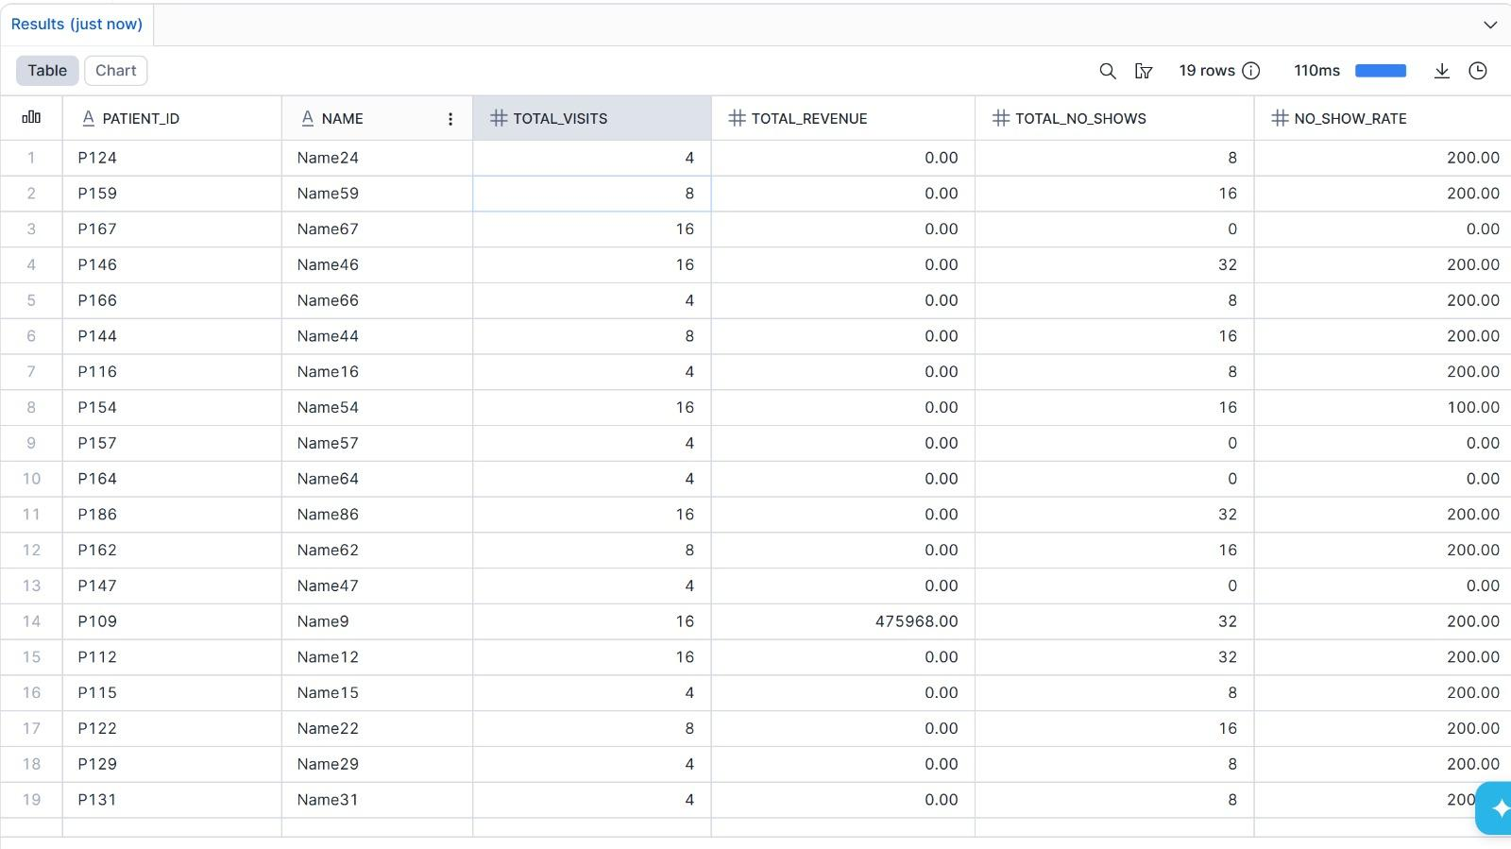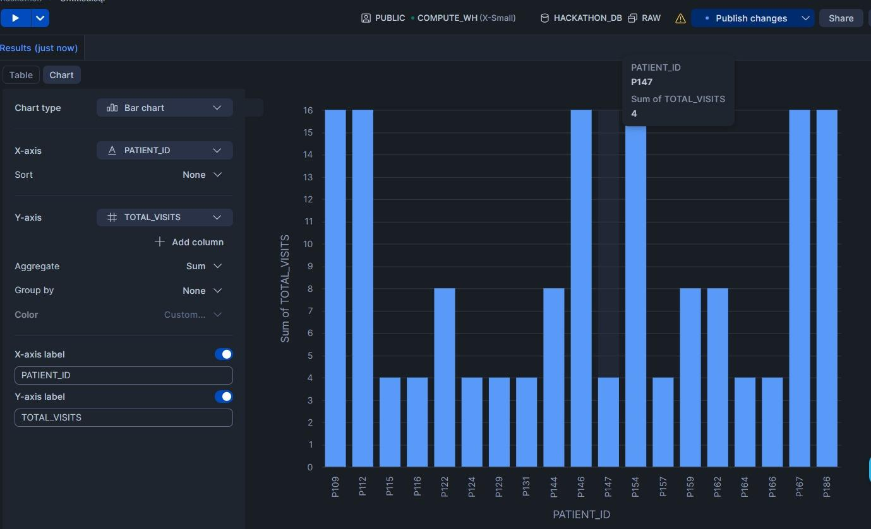

KPI2:KPI_RISK_INDEX
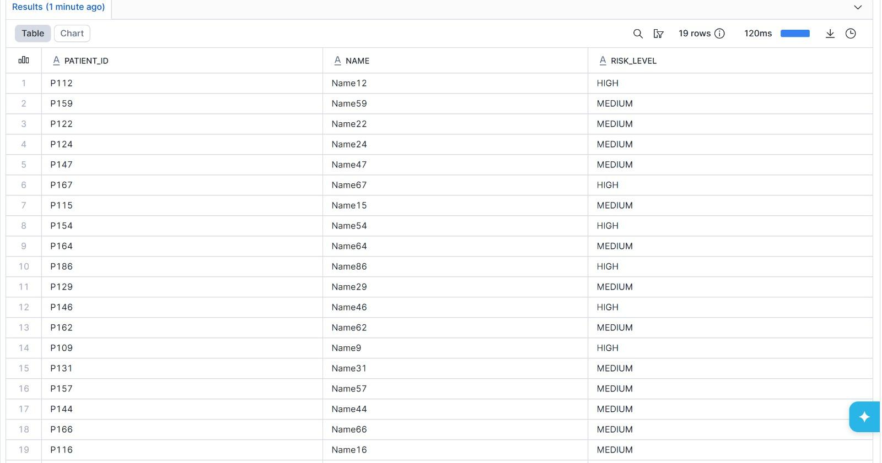

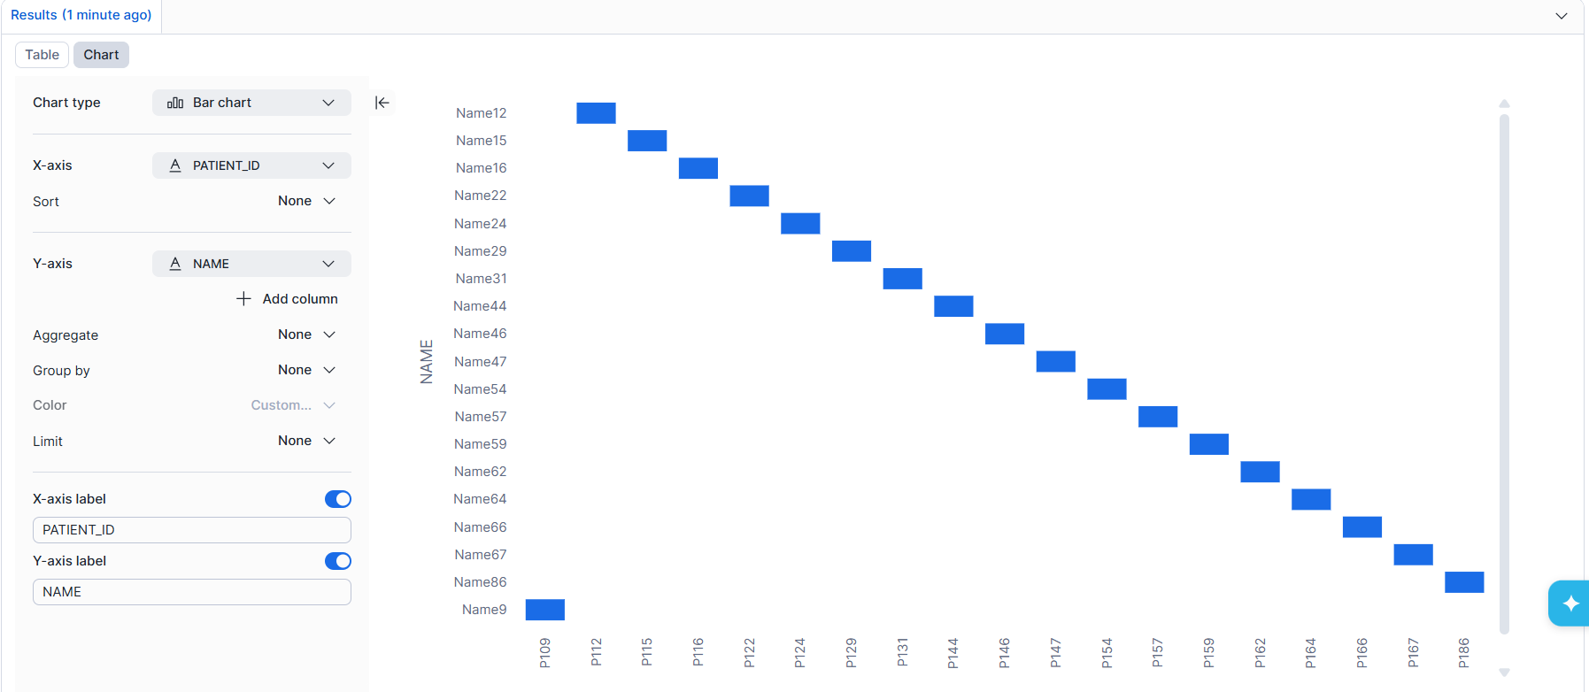

KPI3:KPI_NOSHOWS

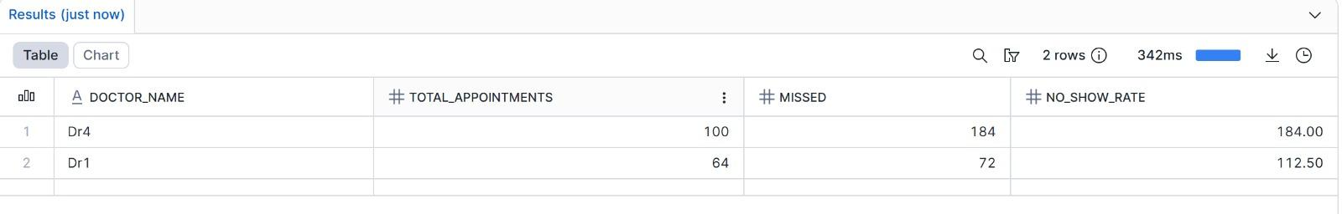

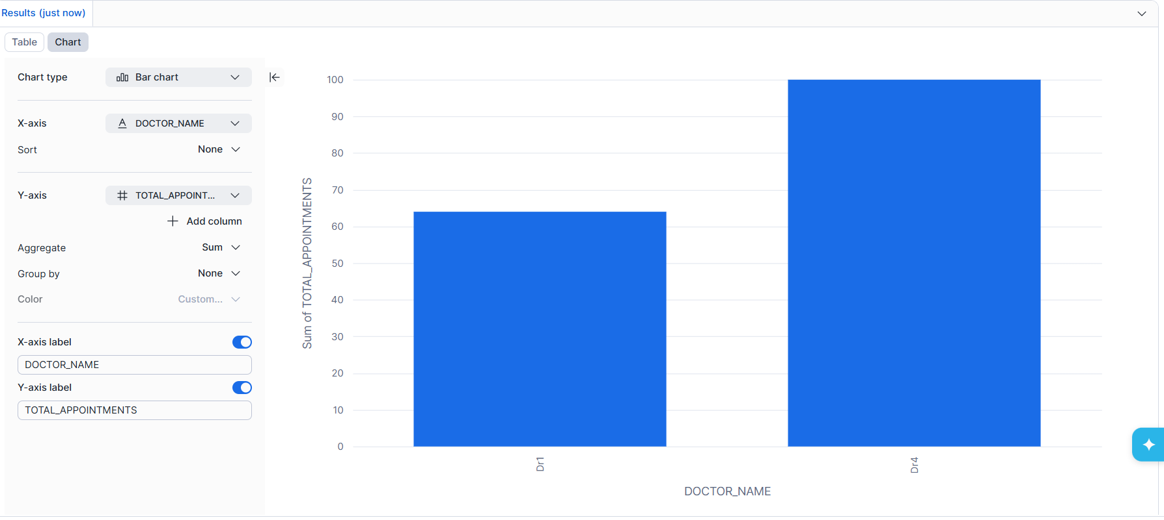

KPI 4:KPI_REVENUE

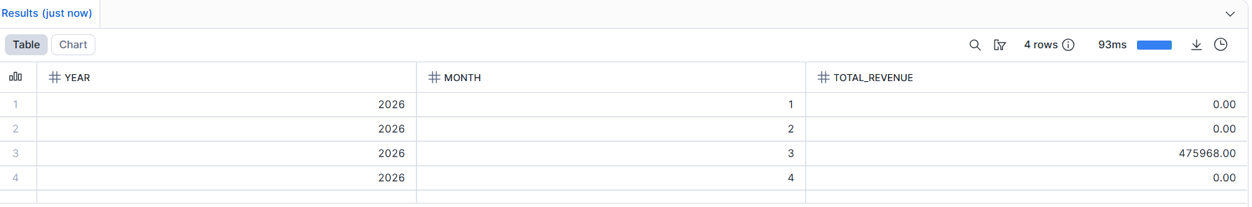

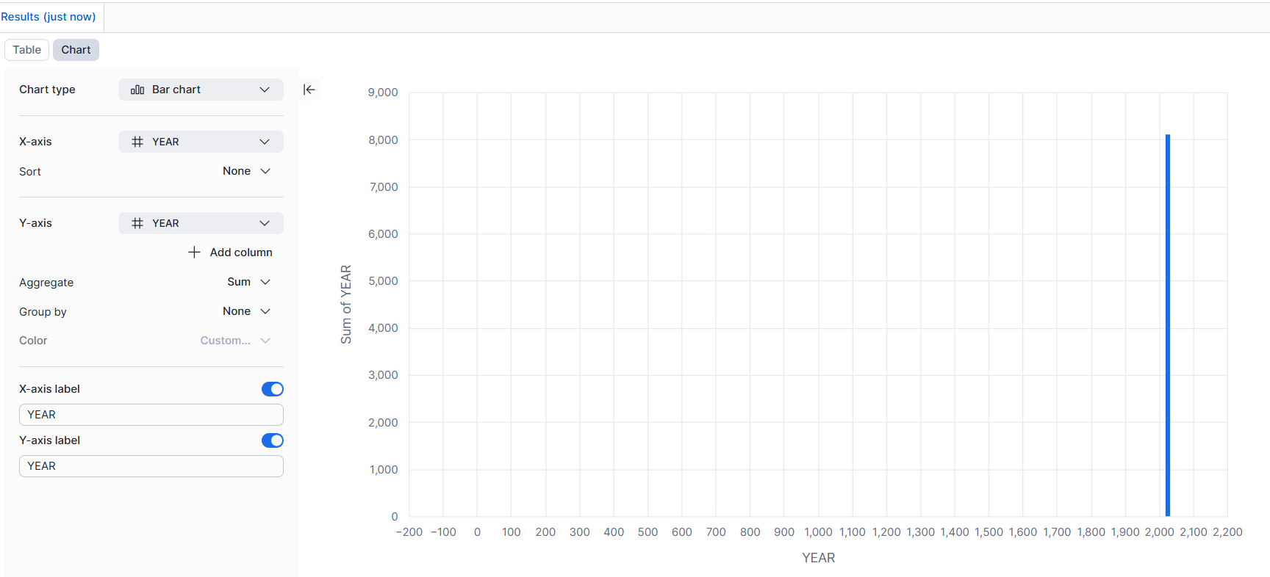
SPRINT 2 : INTEGRATION AND PRESENTATION
We Integrated AWS And Snowflake using Storage Integration &External Staging and used Arn policies to ensure Data is secured and gives access to snowflake for accessing the data from S3.
We used Shared workspace by Using RBAC and granted permissions for respective roles .
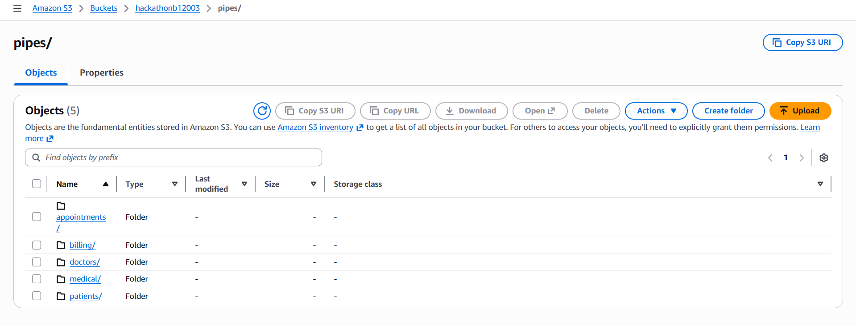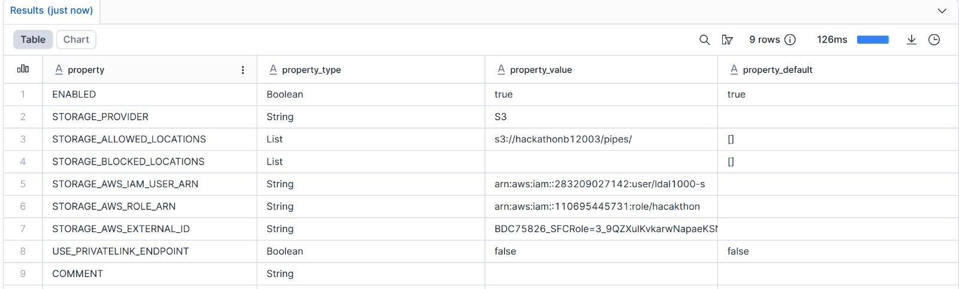

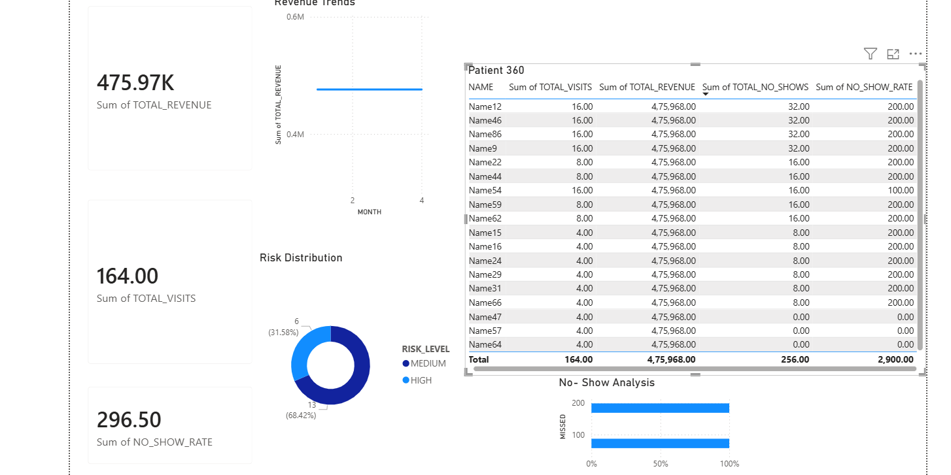

CONCLUSION

This project builds an end-to-end healthcare data pipeline using Snowflake, starting from raw data ingestion to validated cleaning, curated dimensional modeling, and final analytics.

